Spring core and maven

**Exercise 1: Configuring a Basic Spring Application Scenario:**

**Your company is developing a web application for managing a library. You need to use the Spring Framework to handle the backend operations.**

**MainApp.java:**

package com.library; import com.library.service.BookService; import org.springframework.context.ApplicationContext; import org.springframework.context.support.ClassPathXmlApplicationContext; public class MainApp { public static void main(String[] args) {

ApplicationContext context = new ClassPathXmlApplicationContext("applicationContext.xml");

BookService bookService = (BookService) context.getBean("bookService"); bookService.addBook("The Harry Potter");

((ClassPathXmlApplicationContext) context).close();

}

}

**BookRepository.java** package com.library.repository; public class BookRepository

{ public void saveBook(String bookName) {

System.*out*.println("Book '" + bookName + "' saved to the database.");

}

}

**BookService.java** package com.library.service; import com.library.repository.BookRepository; public class BookService {

private BookRepository bookRepository; public void setBookRepository(BookRepository bookRepository) { this.bookRepository = bookRepository;

}

public void addBook(String bookName) { System.*out*.println("Processing the book: " + bookName);

bookRepository.saveBook(bookName);

}

}

**Output:**

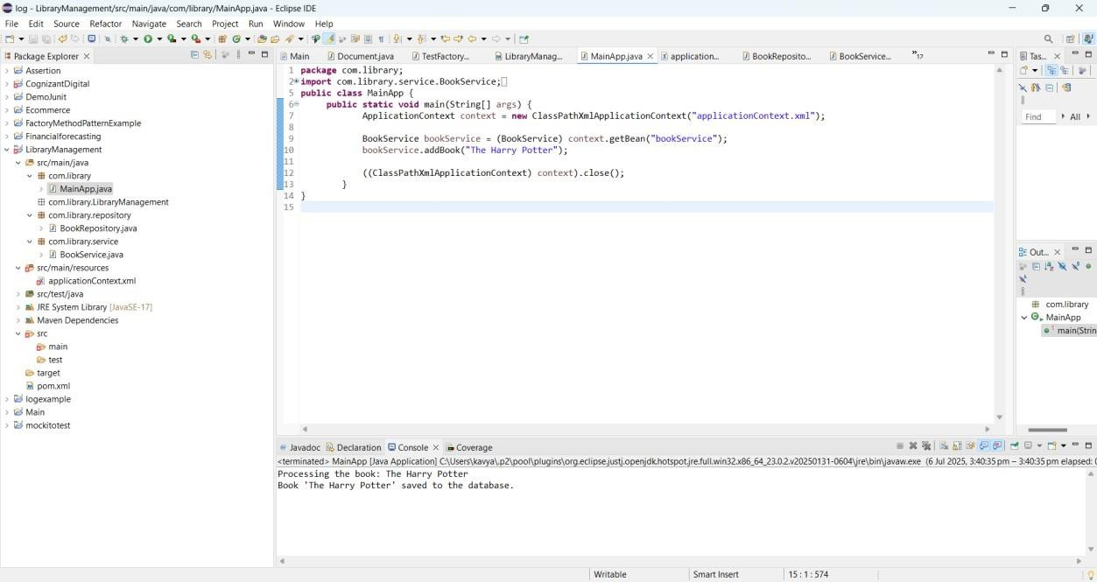

**Exercise 2: Implementing Dependency Injection**

**Scenario:**

**In the library management application, you need to manage the dependencies between the BookService and BookRepository classes using Spring's IoC and DI. MainApp.java**

package com.library.service; import com.library.repository.BookRepository; public class BookService { private BookRepository bookRepository; public void setBookRepository(BookRepository bookRepository) { this.bookRepository = bookRepository;

}

public void addBook(String bookName) {

System.*out*.println("Processing the book: " + bookName); bookRepository.saveBook(bookName);

}

}

**BookRespository.java** package com.library.repository; public class BookRepository { public void saveBook(String bookName) {

System.*out*.println("Book '" + bookName + "' saved to the database.");

}

}

**BookService.java** package com.library.service; import com.library.repository.Book Repository; public class BookService { private BookRepository bookRepository; public void

setBookRepository(BookRe pository bookRepository) { this.bookRepository = bookRepository;

}

public void addBook(String bookName) {

System.*out*.println("Processing the book: " + bookName); bookRepository.saveBook(bookName);

}

}

**Output:**

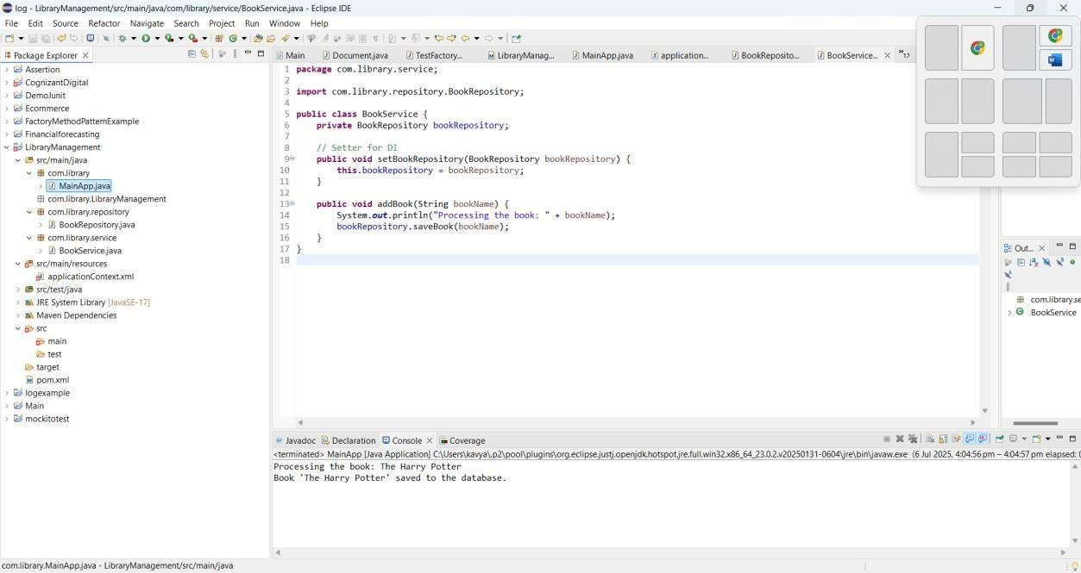

**Exercise 4: Creating and Configuring a Maven Project Scenario:**

**You need to set up a new Maven project for the library management application and add Spring dependencies.**

**Code:**

**MainApp.java** package com.example; import org.springframework.context.ApplicationContext; import org.springframework.context.support.ClassPathXmlApplicationContext; public class MainApp { public static void main(String[] args) {

System.*out*.println("Starting Spring Application...");

ApplicationContext context = new ClassPathXmlApplicationContext("applicationContext.xml");

System.*out*.println("Spring context loaded successfully!");

MessageService service = (MessageService) context.getBean("messageService"); System.*out*.println("Retrieved bean: " + service.getClass().getSimpleName()); service.printMessage();

}

}

**MessageService.java** package com.example; public class MessageService { public void printMessage() {

System.*out*.println("Hello from MessageService! Spring is working!");

}

}

**Output:**

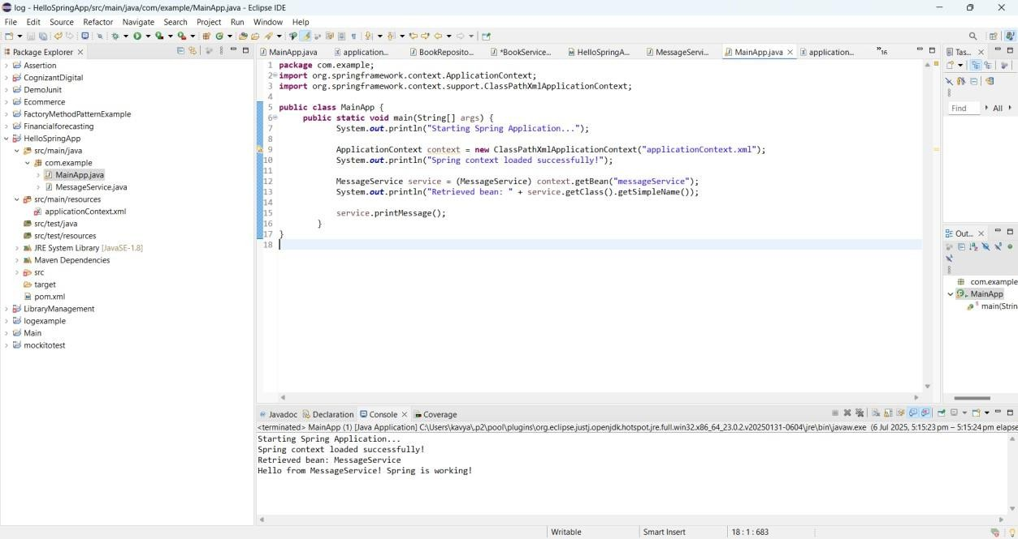

**Spring Data JPA - Quick Example**

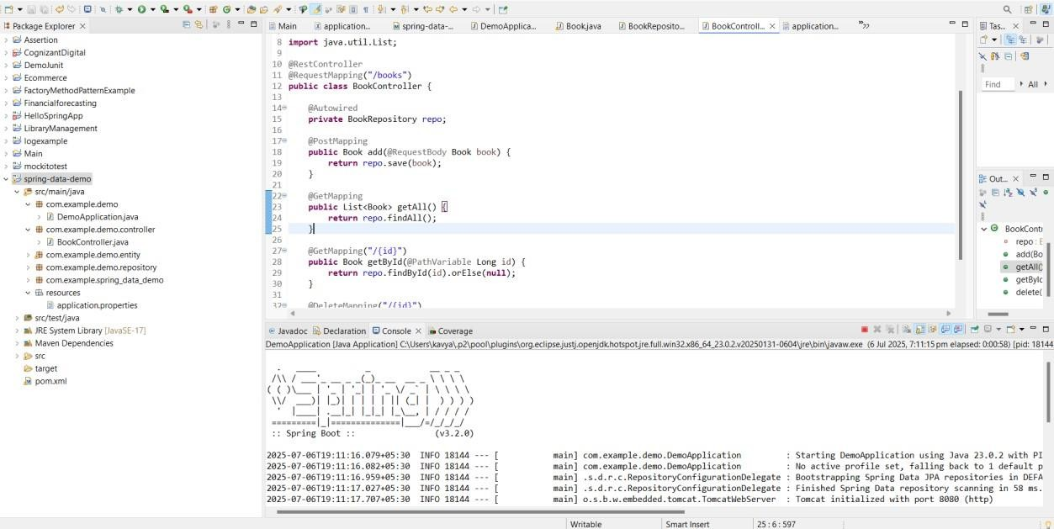

**Difference between JPA, Hibernate and Spring Data JPA**

# JPA (Java Persistence API)

* + It is a specification (interface) provided by Java for ORM (Object-Relational Mapping).
  + JPA provides standard APIs for managing relational data in Java applications.
  + It does not provide implementation, only guidelines.
  + Needs a provider (like Hibernate, EclipseLink) to work.
  + Focuses on entity mapping, query language (JPQL), and transactions.
  + Example annotation: @Entity, @Id, @GeneratedValue.

# Hibernate

* + It is a JPA implementation and a powerful ORM framework.
  + It provides all features required by JPA plus extra features like:

o Caching o

Lazy loading o

Batch processing

* + Supports native Hibernate APIs (like Session) in addition to JPA.
  + Can be used with or without Spring.
  + Has its own query language called HQL (Hibernate Query Language).

# Spring Data JPA

* + It is a Spring project that simplifies the use of JPA in Spring apps.
  + It builds on top of JPA and Hibernate.
  + Reduces boilerplate by providing pre-built repositories like JpaRepository.
  + Supports query method names, custom JPQL, and @Query annotations.
  + Automatically implements CRUD operations and supports pagination and sorting.
  + Great for rapid development of data access layers.